Claude Monet (1840 - 1926)

Monet is one of the defining artists of the Impressionist movement and is famous for his mastery of painting outside, or plein air, in order to capture the effects of natural light. Contemporary audiences viewed his loose and varied brushstroke as sketchy and lacking finish. However, Monet’s decision to reject the polished illusionism of Academic painters, emphasise visible brushstrokes and reject historical and mythological subject matter was highly influential on later movements such as Post-Impressionism and Fauvism. Monet also significantly diverted from the French Salon - the official art exhibition of the Académie des Beaux-Arts - in his choice of subject matter, which included landscapes painted at various times of day in series of works and scenes of everyday life. Monet struggled financially at the beginning of his career but by 1880 he was financially secure and able to pursue projects that were increasingly daring in their formal experimentation. During the 1890s, Monet developed an extensive flower garden at Giverny and built a Japanese-style bridge over a pond where he installed an exotic species of waterlilies. This is the subject of works that he envisioned as a large decorative cycle that would occupy him through the last years of his life and the realisation of which approached almost complete abstraction.

In the 1850s Monet began his career as a caricaturist and attracted the attention of Eugène Boudin, who introduced him to plein air painting. In 1862, Monet left Normandy and went to Paris where he developed friendships with the artists who would later become known as the Impressionists. Monet successfully submitted works to the Salon in 1865, 1866 and 1868; however, his works were rejected in 1867, 1869 and 1870. He submitted works only once more, in 1880. Monet’s lack of participation with the Salon was a sign of the changing focus of avant-garde artists, who rejected the official Salon as the only site for recognition.

Monet continued to develop his plein air technique and, motivated by the earlier generation of Realist artists, painted subjects derived from contemporary life. Monet was also influenced by Japanese prints which inspired him to experiment with asymmetrical compositions and abandon three-dimensional modelling. In 1874, he was instrumental in forming the Société Anonyme des Artistes Peintres, Sculpteurs, Graveurs, better known as the Impressionists. Monet displayed his Impression, Sunrise (1873) at this independent exhibition which prompted the critic Louis Leroy to dub the movement ‘Impressionism’. The 1870s were a time of personal and financial struggle, since Monet’s canvases sold poorly, but, by the mid-1880s, he made a secure living through painting and continued his participation with the Impressionists through seven more exhibitions with the last show occurring in 1886.

In the 1890s Monet worked on several series such as the Grainstacks, the Poplars and Rouen Cathedral. He painted canvases in quick succession (30 - 60 minutes) at the same location in order to capture changing conditions of weather and light. He repeated this system until the canvases were complete. Monet moved to Giverny, France, in 1883 which was his home until his death and the site of his most formally daring works, the waterlily paintings.

References and further reading

House, J. (1986). Monet: Nature into art, New Haven: Yale University Press.

Rewald, J., & Weitzenhoffer, F. (1984). Aspects of Monet: A symposium on the artist's life and times, New York: Abrams.

Sagner-Düchting, K., & Boehm, G. (2001). Monet and modernism, Munich: Prestel.

Stuckey, C. F., & Shaw, S. (1995). Claude Monet: 1840-1926, New York: Thames and Hudson.

Tucker, P. H. (1995). Claude Monet: Life and art, New Haven: Yale University Press.

See image below from Artstor [http://library.artstor.org/library/#1] with their identifying information

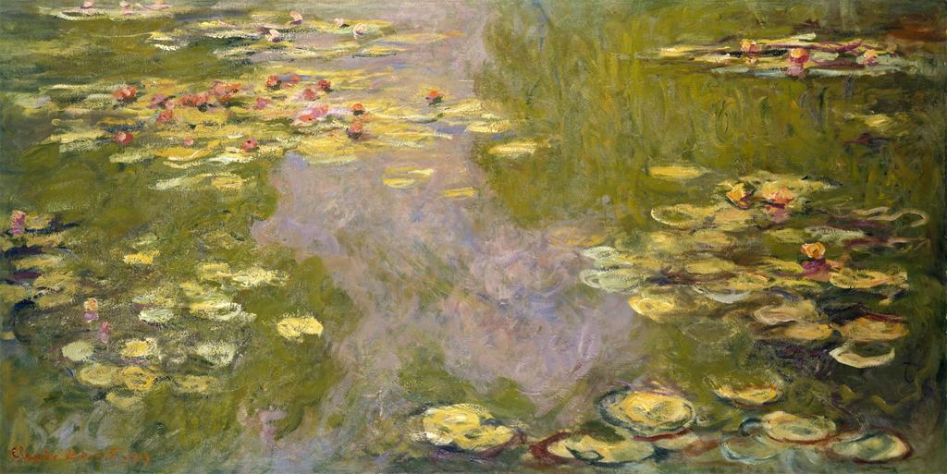

Creator | Claude Monet, French, 1840-1926
Title | Water Lilies
Date | 1919
Material | Oil on canvas
Measurements | 39 3/4 x 78 3/4 in. (101 x 200 cm)
Description | Signed and dated (lower left): Claude Monet 1919
Credit Line | The Metropolitan Museum of Art, The Walter H. and Leonore Annenberg Collection, Gift of Walter H. and Leonore Annenberg, 1998, Bequest of Walter H. Annenberg, 2002 (1998.325.2)
Image Copyright Notice | Image ? The Metropolitan Museum of Art
Repository | The Metropolitan Museum of Art  http://www.metmuseum.org
ARTstor Collection | Metropolitan Museum of Art - Images for Academic Publishing
ID Number | 2464
Source | Data From: The Metropolitan Museum of Art
Rights | This image was provided by The Metropolitan Museum of Art. Contact information: Image Library, The Metropolitan Museum of Art, 1000 Fifth Avenue, New York, NY 10028, (212) 396-5050 (fax), Scholars.License@MetMuseum.org  Image ? The Metropolitan Museum of Art  This image is available for uses permitted under the ARTstor Terms and Conditions of Use, such as teaching and study, as well as for scholarly publications, through the Images for Academic Publishing (IAP) initiative. If you are seeking to use this image for scholarly publication, you should click on the IAP icon below the thumbnail image.
Download Size | 10,241,024

